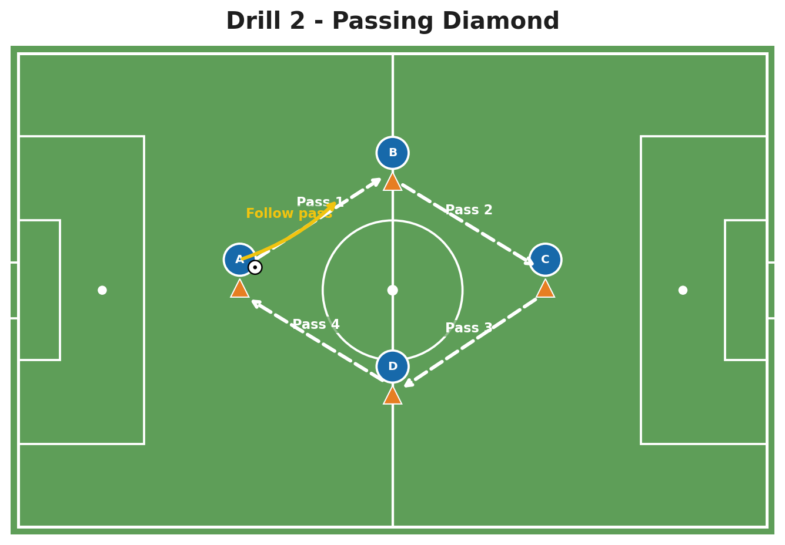
SOCCER DRILL DESIGN
& MEDIA GUIDE
How to plan, diagram, animate, film, and share effective coaching drills

Designed for: Grassroots, academy, school, and club coaches who need a repeatable way to explain training activities clearly.

Includes six ready-to-use drills, a drill-design canvas, a filming checklist, and companion GIF/MP4 animation files.

How to Use This Guide
Use the guide in two ways: first as a coaching framework, then as a production workflow. The goal is not to make fancy media. The goal is to make the drill easy to understand before players step onto the field.
- Design the learning outcome and rules before drawing anything.
- Build a clean static diagram using the visual language in this guide.
- Add movement in PowerPoint, Canva, or specialist coaching software.
- Film the live drill from a useful angle and annotate only the key moments.
- Save the drill using a consistent file name so it can be reused by every coach.
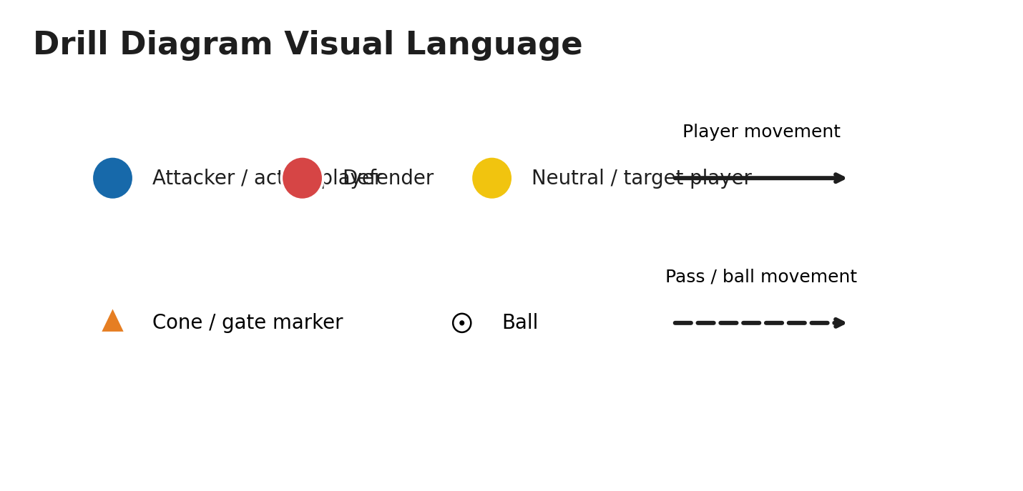
The PDF version shows a still image from the companion animation. The Word file can be edited. The separate GIF and MP4 demonstrate the animated passing sequence.

Contents and File Bundle
The package includes an editable Word guide, a print-ready PDF, an animated GIF, and an MP4 video. Use the Word file to customize drills, the PDF for field-side reference, and the media files as examples for your own animations.
1 | The drill-design framework
2 | Field setup and delivery
3 | Static diagrams
4 | Animations
5 | Filming and video analysis
6 | Six sample drills
7 | Session planning
8 | Templates and checklists

Recommended workflow
Plan | Diagram | Animate | Film | Review
Outcome + rules | Starting picture | Sequence + timing | Wide + close clip | Keep only useful media
Best practice: Keep the PDF and diagram simple. Deliver movement through the separate MP4 or GIF so the animation plays reliably on phones, laptops, and team platforms.

1. The Drill-Design Framework
A useful drill starts with one observable behaviour. “Improve passing” is too broad. “Receive on the back foot and play forward within two touches” gives the coach, players, and video editor something specific to look for.
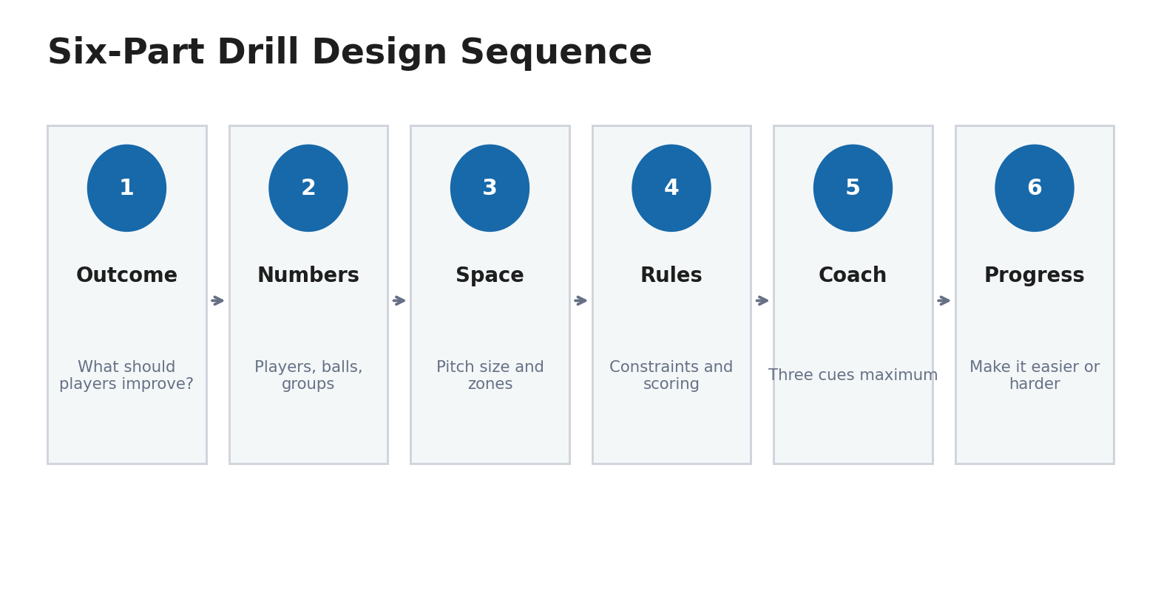

The six decisions
1. Outcome - Write one sentence beginning with: “By the end of this drill, players will…”
2. Numbers - Choose individual, pair, unit, or team work. Avoid long lines and inactive players.
3. Space - Set the area to create the behaviour. Smaller space increases pressure; larger space increases time and running.
4. Rules - Use one or two constraints, such as two-touch play, directional targets, time limits, or bonus points.
5. Coaching cues - Choose no more than three short cues. Freeze the drill only when the whole group benefits.
6. Progression - Plan how to increase challenge and how to simplify the activity if success is too low.
Success-rate guide: For skill learning, aim for enough difficulty that players must solve problems, but not so much that the activity collapses. As a practical coaching estimate, adjust space, pressure, or rules when success is consistently below about 50% or above about 85%.

Drill Design Canvas
Complete this page before building the diagram or recording the drill. It becomes the specification for the coach and the media creator.
Drill name
Learning outcome | By the end, players will…
Players and groups
Area and equipment
Rules and scoring
Three coaching cues | 1.  2.  3.
Progression / regression
How success will be measured

Age and stage adjustments
Stage | Main need | Coach language | Typical activity length
U6-U8 | Ball contact, fun, direction changes | One instruction at a time | 45-90 seconds
U9-U12 | Technique under light pressure | Show, play, brief correction | 2-4 minutes
U13-U16 | Scanning, decisions, unit tactics | Use questions and game references | 3-6 minutes
Older youth/adult | Game model, role clarity, intensity | Link actions to match problems | 4-8 minutes

2. Field Setup and Delivery

Equipment checklist
- Cones or flat markers in at least two colours
- One ball per player for technical work; extra balls near the coach for game activities
- Bibs in two or three colours
- Portable goals or cone gates
- Whistle, timer, clipboard/tablet, and first-aid access
- Tripod or stable phone mount when filming

Ten-minute setup routine
- Walk the space and remove hazards.
- Build the largest activity first, then place smaller warm-up areas inside it.
- Put spare balls where restarts will happen.
- Place bibs and equipment by group before players arrive.
- Stand where every player can see the demonstration without facing the sun.
- Demonstrate at game speed once, then slowly once.
- Start play quickly. Add detail after players have experienced the problem.

Coach position
Stand where you can see the action, the next pass, and the off-ball players. Avoid living inside the drill. Move around the outside, then step in only for a short intervention. When filming, keep the coach out of the main camera lane whenever possible.

A clear coaching intervention
Observe | Stop | Show | Restart
Confirm the pattern repeats | Freeze only if many players benefit | Use one cue and a quick picture | Replay from just before the moment
Keep players active: Long explanations reduce repetitions and make video less useful. A good rule is to coach for less time than the players were just active.

3. Creating Static Drill Diagrams
A diagram should answer four questions in five seconds: Where is the area? Where do players start? Where does the ball go? What is the first movement?

Use a consistent visual language
- One colour for attackers, one for defenders, and a third for neutral players or goalkeepers.
- Solid arrows for player movement; dashed arrows for the ball.
- Number sequences only when order matters.
- Show the starting picture, not every possible outcome.
- Keep text outside the field whenever possible.

Fast method: PowerPoint or Google Slides
- Insert a green rectangle and add white pitch lines, or use a legally licensed pitch template.
- Create one player marker, one cone, one ball, and two arrow styles.
- Duplicate objects rather than redrawing them so size stays consistent.
- Group each player label with its circle.
- Add a short title, objective, and three coaching cues.
- Export the slide as PNG for a session plan or as PDF for printing.

Fast method: Canva
Canva works well for branded handouts, social clips, and simple animated explainers. Build the pitch and symbols once, lock the background, duplicate the page, and change only the movements. Canva supports presentations, video creation, and object/page animation, so the same design can become a handout or a short video.

Specialist method: TacticalPad
TacticalPad is designed specifically for drills, formations, and session planning. Its current product materials describe 2D/3D animation, sharing, and support across desktop and mobile platforms. Use a specialist tool when several coaches need a repeatable library rather than one-off graphics.

4. Creating Drill Animations
Animation should reveal sequence and timing. It should not attempt to show every decision. Build one phase at a time: starting positions, first pass, supporting run, next action, reset.
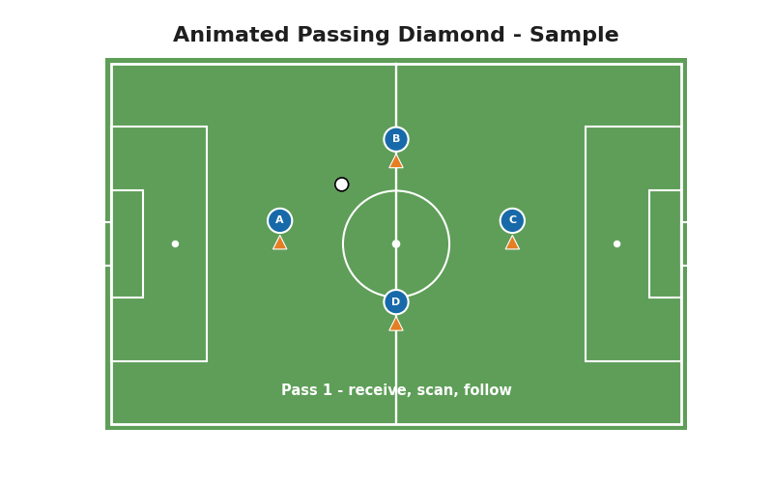
Companion files: sample_passing_diamond_animation.gif and sample_passing_diamond_animation.mp4

Option A: PowerPoint motion paths
- Create the starting diagram on one slide.
- Select a player or ball object, then choose Animations > Add Animation > Motion Paths.
- Draw or edit the path so the object finishes exactly where the next action begins.
- Open the Animation Pane and set the sequence to On Click, With Previous, or After Previous.
- Use short durations for the ball and slightly longer durations for supporting runs.
- Export the slide deck as MP4, or screen-record the presentation with narration.
Animation rule: The ball normally moves faster than players. If every object moves at the same speed, the animation looks artificial and can teach the wrong timing.

Option B: TacticalPad
- Place players, equipment, and zones on the pitch.
- Create animation steps rather than one long movement.
- Use 2D for teaching clarity; use 3D only when the viewing angle adds information.
- Add short notes for the coach, then export or share the visual with the team.

Option C: Canva
- Duplicate pages to create a storyboard of positions.
- Use element animations or page transitions for simple movement.
- Record a voice-over or talking-head explanation when context matters.
- Export a short MP4 for team chat, learning platform, or social media.

Animation storyboard template
Step | What moves? | Coach message | Duration
1 |  |  | 1-3 sec
2 |  |  | 1-3 sec
3 |  |  | 1-3 sec
4 |  |  | 1-3 sec
5 |  |  | 1-3 sec

5. Filming and Video Analysis

Before filming
- Follow your club, league, school, and local rules for consent and youth privacy.
- Tell players what is being recorded, why it is being recorded, and who will receive it.
- Avoid posting identifiable youth footage publicly unless proper permission is in place.
- Charge the phone, clear storage, use airplane/do-not-disturb mode, and test the frame.

Recommended camera angles
Angle | Best for | Risk
High and wide | Shape, spacing, pressing, support | Harder to see technique
Side-on | Passing mechanics, running lines, timing | Players can overlap in frame
Behind goal/end line | Finishing, goalkeeper, defensive line | Limited view of build-up
Close detail | First touch, body shape, striking technique | Loses tactical context

Simple filming workflow
- Record a 5-10 second empty-field setup shot.
- Record the coach demonstration.
- Record one wide block without stopping the camera.
- Capture one close angle only if it supports the learning outcome.
- Mark the best moments immediately after training so they are easy to find.
- Edit to the shortest clip that proves the coaching point.

Annotating live video
Coach Paint is built for sports video analysis and offers telestration-style graphics for highlighting players, spaces, and actions. Use annotations sparingly: one circle, one line, and one sentence are often enough. Freeze before the decision, ask the player what they see, then play the outcome.

A useful 45-second teaching clip
Time | Visual | Audio/text
0-5 sec | Title and starting diagram | State the one outcome
5-15 sec | Animation or coach demo | Explain the first two actions
15-35 sec | Live drill clip | Pause once to highlight the cue
35-45 sec | Successful repetition | Repeat the cue and next challenge

6. Six Ready-to-Use Drills

Drill 1: Gate Dribbling
Objective | Change direction with close control while scanning for space. | Ages | U6-U12
Players | 6-16 | Area | 25 x 20 yards; adjust to numbers
Equipment: 1 ball per player, 12-20 cones
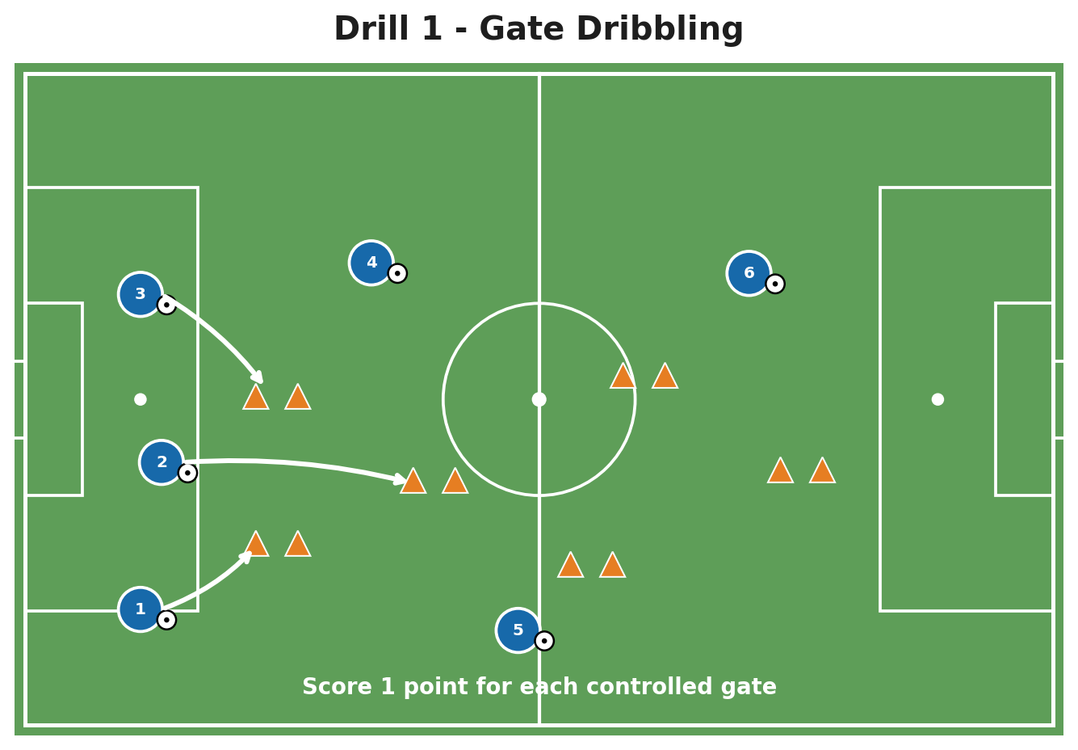
Figure 1. Gate Dribbling setup and movement.

Setup
- Create 6-10 cone gates spread through the area.
- Every player starts with a ball.
- Gates should be wide enough for early success.

Rules and scoring
- Players score one point each time they dribble through a new gate.
- They cannot use the same gate twice in a row.
- Play 45-75 seconds, then change the challenge.

Coaching cues
- Small touches near pressure.
- Eyes up between touches.
- Accelerate after the turn.
Progressions | Regressions
• Use only the weaker foot.  • Add a defender who can steal any ball.  • Different turns earn different points. | • Increase gate width.  • Remove defenders.  • Allow players to stop the ball before turning.

Drill 2: Passing Diamond
Objective | Pass accurately, receive across the body, and support the next action. | Ages | U9-adult
Players | 4-8 per diamond | Area | 12-18 yard diamond
Equipment: 4 cones, 1-2 balls
Figure 2. Passing Diamond setup and movement.

Setup
- Place one player at each cone; add extra players behind the starting cone.
- The ball travels around the diamond.
- Players follow their pass to the next cone.

Rules and scoring
- Begin with two-touch play.
- Pass to the outside foot of the receiver.
- Reverse direction every 2-3 minutes.

Coaching cues
- Scan before the ball arrives.
- First touch away from pressure.
- Pass firmly and follow quickly.
Progressions | Regressions
• Add a second ball.  • Use one-touch play on selected passes.  • Add a wall pass at one corner. | • Make the diamond smaller.  • Remove the follow run until passing rhythm improves.  • Allow a controlling touch before opening the body.

Drill 3: 4v2 Rondo
Objective | Keep possession using support angles, scanning, and quick decisions. | Ages | U10-adult
Players | 6 per group | Area | 10 x 10 to 15 x 15 yards
Equipment: 4 cones, 1 ball, bibs
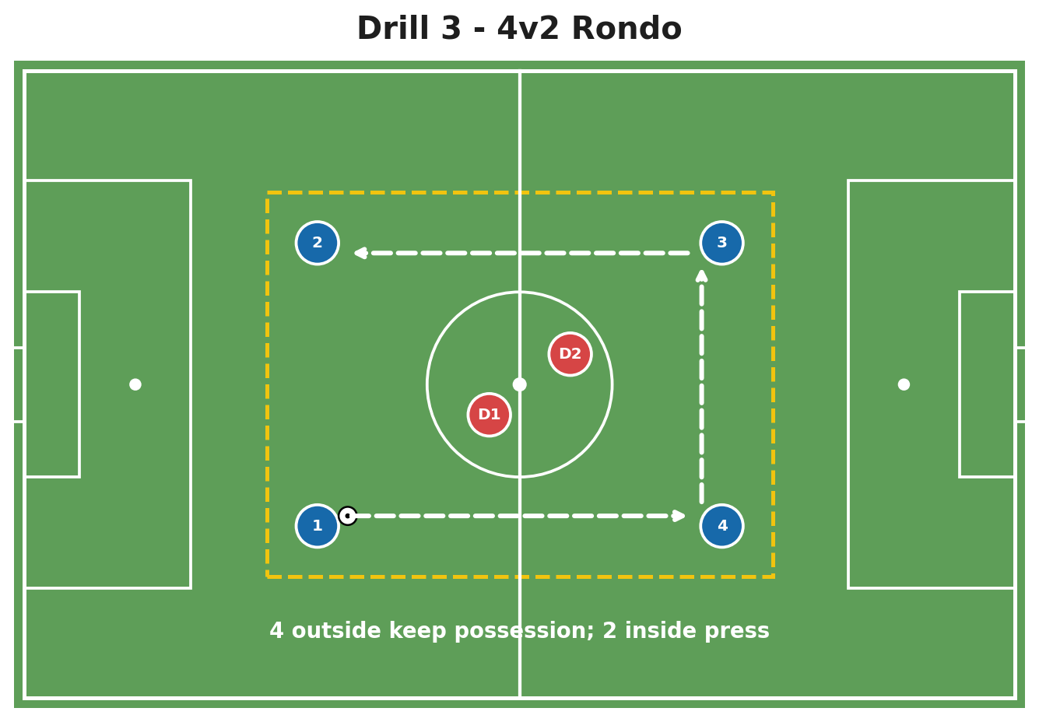
Figure 3. 4v2 Rondo setup and movement.

Setup
- Four attackers occupy the outside; two defenders work inside.
- Adjust the square so attackers can succeed but must move the ball quickly.
- Keep spare balls beside the coach.

Rules and scoring
- Attackers score one point for five consecutive passes.
- Defender who wins the ball swaps with the player who lost it, or rotate after 45 seconds.
- Start unlimited touch, then move to two-touch.

Coaching cues
- Create two passing options.
- Receive on the far foot.
- Move after every pass.
Progressions | Regressions
• Require a split pass between defenders.  • Add transition: defenders escape the square after winning.  • Shrink the area. | • Increase the area.  • Use one defender.  • Allow an outside neutral who cannot be pressed.

Drill 4: 3v2 Transition to Goal
Objective | Attack quickly with width, a central option, and a clear final decision. | Ages | U12-adult
Players | 6-12 plus goalkeeper | Area | Half field or 35 x 30 yards
Equipment: Goal, balls, bibs, cones
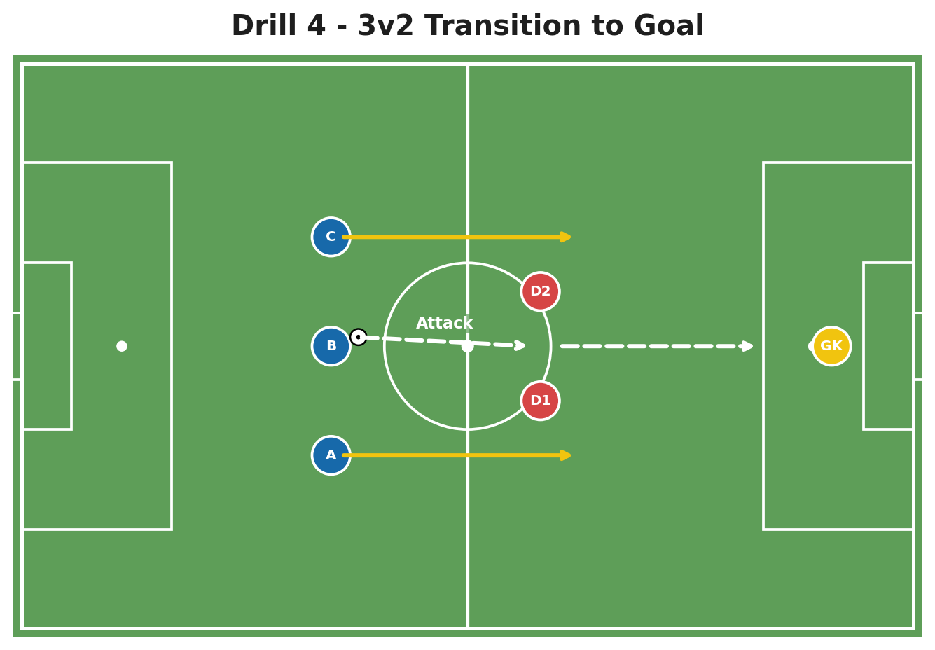
Figure 4. 3v2 Transition to Goal setup and movement.

Setup
- Three attackers begin 25-35 yards from goal against two defenders.
- Coach serves the ball to the central attacker.
- Next group is ready immediately after the shot or turnover.

Rules and scoring
- Attackers have 8-10 seconds to finish.
- Defenders score by winning and passing into a target gate.
- Rotate roles every 3-4 repetitions.

Coaching cues
- First touch forward.
- Use width to stretch two defenders.
- Pass when the defender commits.
Progressions | Regressions
• Add a recovering defender.  • Require a cutback finish.  • Start from a turnover instead of a coach pass. | • Remove the time limit.  • Start defenders deeper.  • Use 3v1 before returning to 3v2.

Drill 5: Four-Goal Small-Sided Game
Objective | Recognize space, switch the point of attack, and defend multiple threats. | Ages | U9-adult
Players | 4v4 to 7v7 | Area | 30 x 25 to 45 x 35 yards
Equipment: 8 cones, balls, bibs
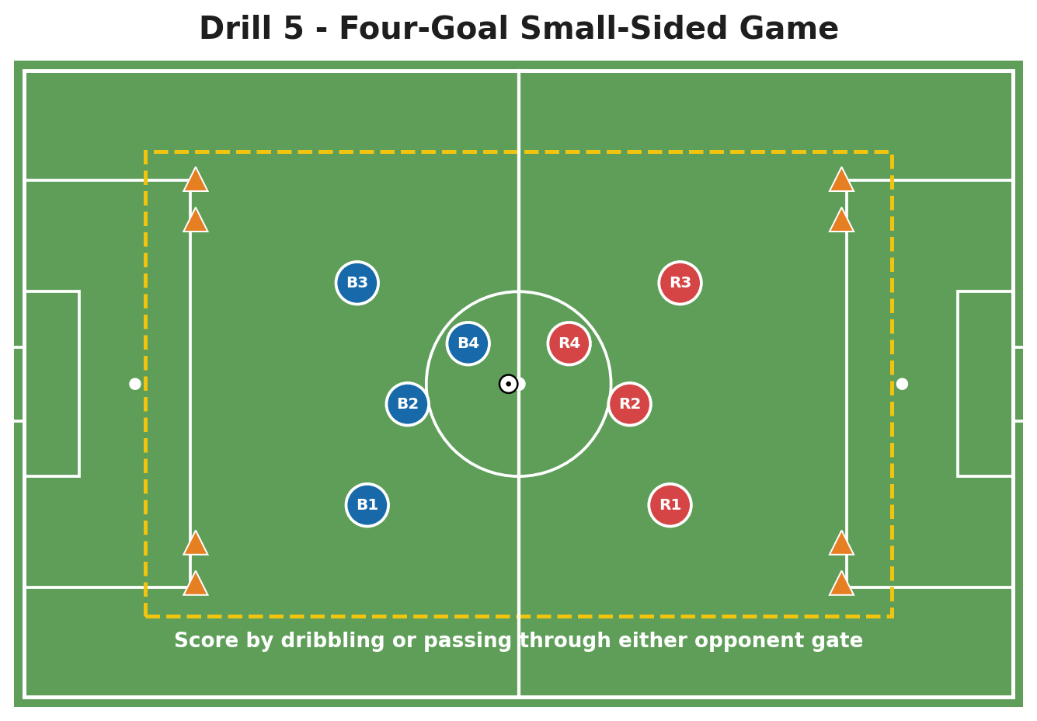
Figure 5. Four-Goal Small-Sided Game setup and movement.

Setup
- Create two small gates on each end line.
- Teams attack the two gates opposite them.
- Keep spare balls around the field for fast restarts.

Rules and scoring
- Score by passing or dribbling through either gate.
- A team cannot score in the same gate twice in a row.
- Play 3-5 minute games.

Coaching cues
- Look away from pressure.
- Make the field big in possession.
- Protect the middle when defending.
Progressions | Regressions
• Bonus point after a switch of play.  • Add neutral wide players.  • Limit touches in the central zone. | • Increase field size.  • Allow a goal in any gate after a turnover.  • Play with one neutral to create an overload.

Drill 6: Combination and Finish
Objective | Coordinate pass timing, supporting runs, and a composed finish. | Ages | U11-adult
Players | 5-12 plus goalkeeper | Area | 25-35 yards from goal
Equipment: Goal, balls, 3-5 cones
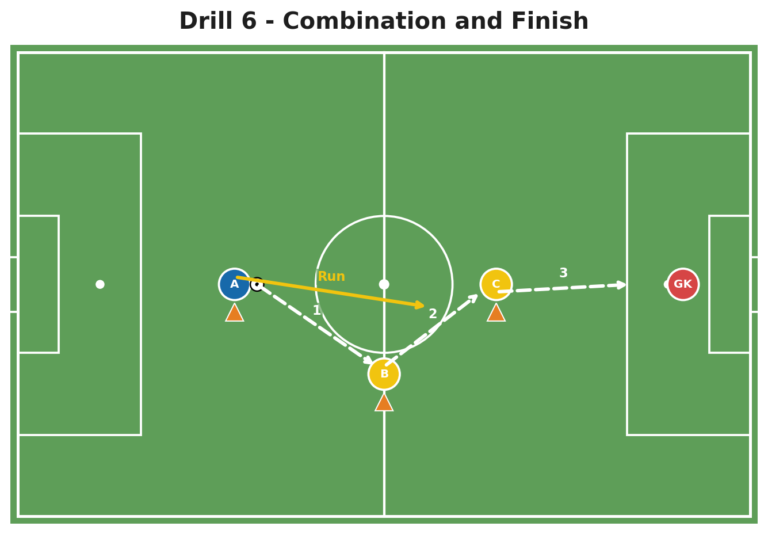
Figure 6. Combination and Finish setup and movement.

Setup
- A starts with the ball, B and C act as target players, and the goalkeeper is set.
- A passes to B, receives or runs beyond, then the ball is set through C for a finish.
- Rotate A to B, B to C, C to the starting line.

Rules and scoring
- Start unopposed to establish timing.
- Finish within two touches.
- Use both sides of the goal.

Coaching cues
- Pass to the correct foot.
- Run after the ball travels.
- Finish early when the goalkeeper is set.
Progressions | Regressions
• Add a recovering defender.  • Make B or C choose between two combinations.  • Add a second finish from a rebound. | • Use stationary target players.  • Allow unlimited touches.  • Shorten the distances.

7. Building a Complete Session
A session should move from simple information to realistic decisions. The final activity should contain the same problem as the earlier drill, but with more freedom.

60-minute example
Block | Minutes | Purpose | Coach focus
Arrival activity | 8 | Ball contact and engagement | Observe; minimal interruption
Technical drill | 12 | Introduce the skill | Technique and repetition
Opposed practice | 15 | Add pressure and choices | Scanning and timing
Small-sided game | 20 | Transfer to game decisions | Coach the theme, not every error
Review | 5 | Recall key cues | Players explain learning

90-minute example
Block | Minutes | Purpose | Coach focus
Movement/ball warm-up | 12 | Prepare body and ball | Tempo and coordination
Technical pattern | 15 | Build the action | Details and rhythm
Positional practice | 20 | Add teammates and opponents | Spacing and roles
Phase/transition game | 18 | Connect to match moment | Speed of decision
Conditioned game | 20 | Game transfer | Observe team behaviours
Review/cool down | 5 | Reflect and reset | One success, one next step
Session connection test: Every block should reinforce the same learning outcome. If the warm-up, technical drill, and game teach unrelated ideas, the session becomes a collection of activities rather than a coaching plan.

8. Templates and Checklists

Pre-session production checklist
☐ | Outcome written in one sentence | ☐ | Progression and regression planned
☐ | Player numbers and groups confirmed | ☐ | Static diagram exported
☐ | Area dimensions chosen | ☐ | Animation or demo prepared
☐ | Equipment and spare balls listed | ☐ | Consent/privacy requirements checked
☐ | Three cues selected | ☐ | Camera angle and storage tested

Recommended file structure
Soccer_Drill_Library/
Age_Group/
Topic/
Drill_Name_v01.docx
Drill_Name_diagram.png
Drill_Name_animation.mp4
Drill_Name_live_clip.mp4
Drill_Name_notes.txt

File naming convention
Use: AGE_TOPIC_FORMAT_DRILL_VERSION. Example: U12_Passing_Rondo_4v2_v03.mp4. A standard name makes the library searchable and prevents coaches from sharing “final-final-new” files.

After-session review
- Did the activity create the intended behaviour?
- What percentage of players were active?
- Was the space too large or too small?
- Which coaching cue changed behaviour?
- What should be removed, simplified, or progressed next time?
- Which video clip is worth keeping in the drill library?

Software Resources and Source Notes
The workflows in this guide can be completed with general presentation/video software or specialist coaching platforms. Product features can change; verify the current plan and device support before purchasing.
- Microsoft Support - Add a motion path animation effect - Official instructions for creating and editing motion paths in PowerPoint.
- Microsoft Support - Animate text or objects - Official overview of animation timing and the Animation Pane.
- TacticalPad - Official product page describing drill/session planning and 2D/3D animations.
- Coach Paint - Official sports video-analysis and telestration platform.
- Canva Magic Animate - Official animation feature overview.
- Canva Video Presentations - Official page for presentation recording and video creation.

Choosing a production method
Need | Simplest option | Specialist option | Output
Printable diagram | PowerPoint / Canva | TacticalPad | PNG or PDF
Player movement animation | PowerPoint / Canva | TacticalPad | MP4 or GIF
Live video annotation | Presentation overlays | Coach Paint | Annotated MP4
Branded teaching clip | Canva / PowerPoint | Combined workflow | MP4
Important limitation: Animations embedded in Word or online presentations may not play after export to PDF. For reliable sharing, include a still diagram in the PDF and attach or link the MP4/GIF separately.

Printable Drill Planning Sheet
Drill name
Age / level
Learning outcome
Players / groups
Area / equipment
Setup
Rules / scoring
Three coaching cues | 1.  2.  3.
Progression / regression
Video / animation plan

